*\*\*\*Enclosed are the files for the mechanical components of our project. You’ll find scale models of the filter circuits and the Arduino Leo (see full assembly file for general placement), as well as the 3D-printed central shelf and battery holder, and the sheet metal case. For convenience, we have included STL and Solidworks files of all the case components. 3D-printable electrode files can be found in the STL file.*

**Metal Case:** The metal case acts as a Faraday’s Cage, protecting the internal electrical components from unwanted electromagnetic fields. The metal case is made out of thin aluminum metal sheets and assembled using Epoxy Glue and tape to form the rectangular shape. The following dimensions were used to construct the metal case, such that they would fit the 3D printed shelf:

* Height: 36mm - 38mm
* Width: 66mm - 68mm
* Length: 135mm - 138mm

**Electrodes:** We decided to 3D print our electrodes using PLA plastic and coated them with conductive silver paint (Hisco Brand, 45% Purity) because this method was quick, cheap and allowed our team to iterate upon designs. The data sheet for the silver paint we used can be found here: <https://www.electrolube.com/core/components/products/tds/044/SCP.pdf> This idea was inspired by the following article: [www.mdpi.com/1424-8220/16/10/1635/pdf](http://www.mdpi.com/1424-8220/16/10/1635/pdf)

The following types of electrodes were constructed for this project:

1. **Concave Electrodes:**

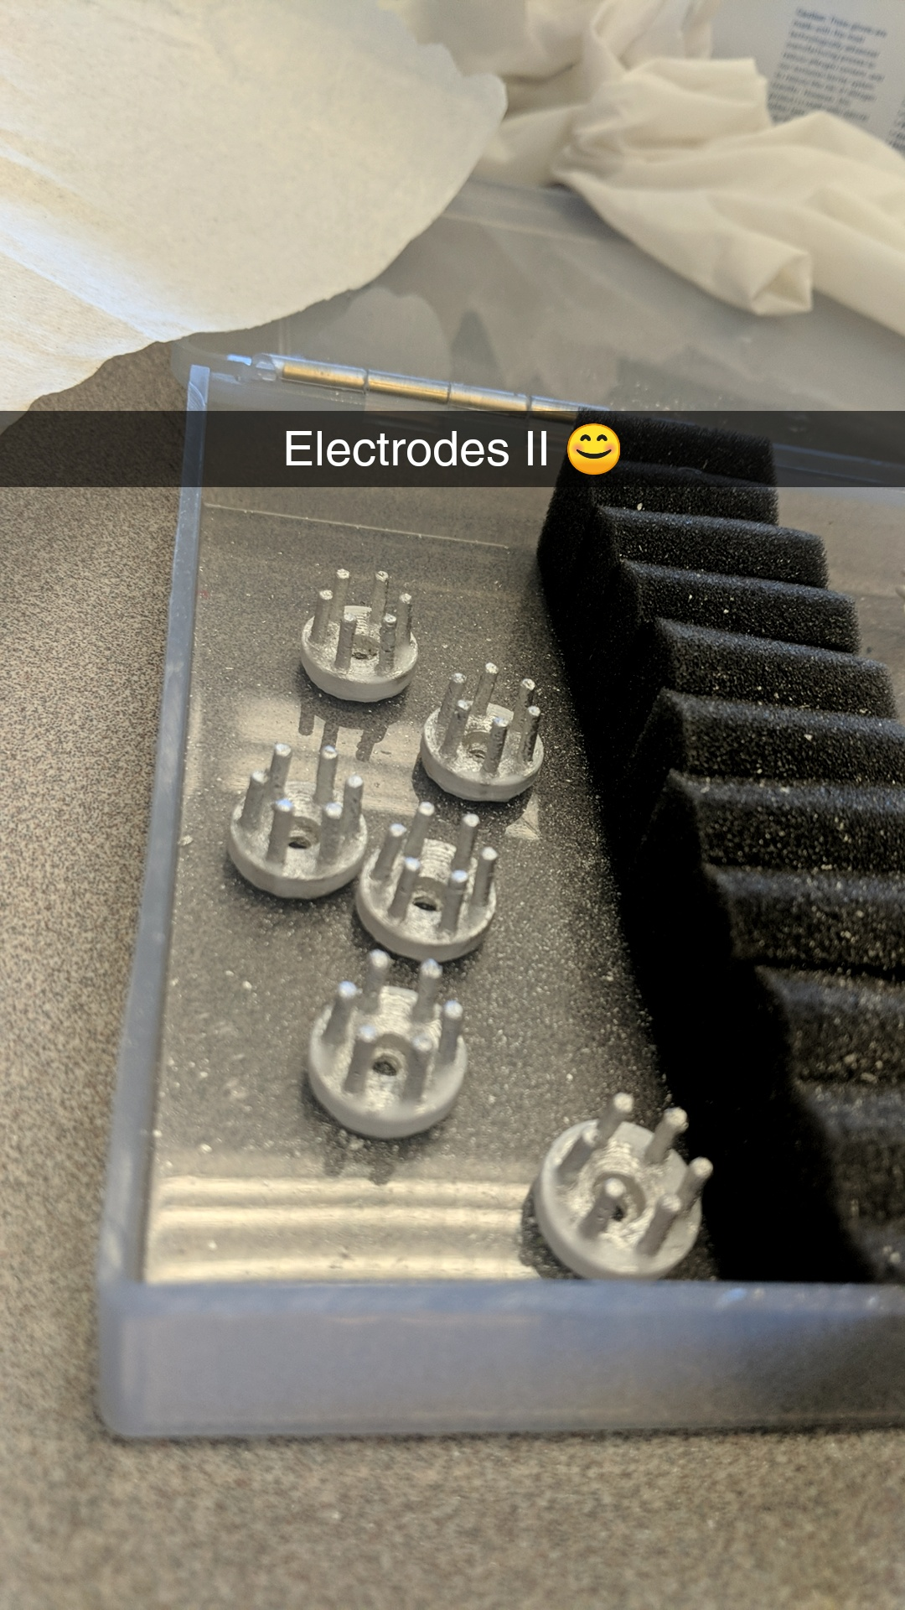

These electrodes were designed to contain ‘spikes’ that penetrate through the hair and maximize contact area with the scalp. The dimensions of the electrodes can be found on the STL and Solidworks files. They have screw holes that allow them to be secured to any sort of hair band, headset or holder.

B) **Hair Clip Electrodes:**

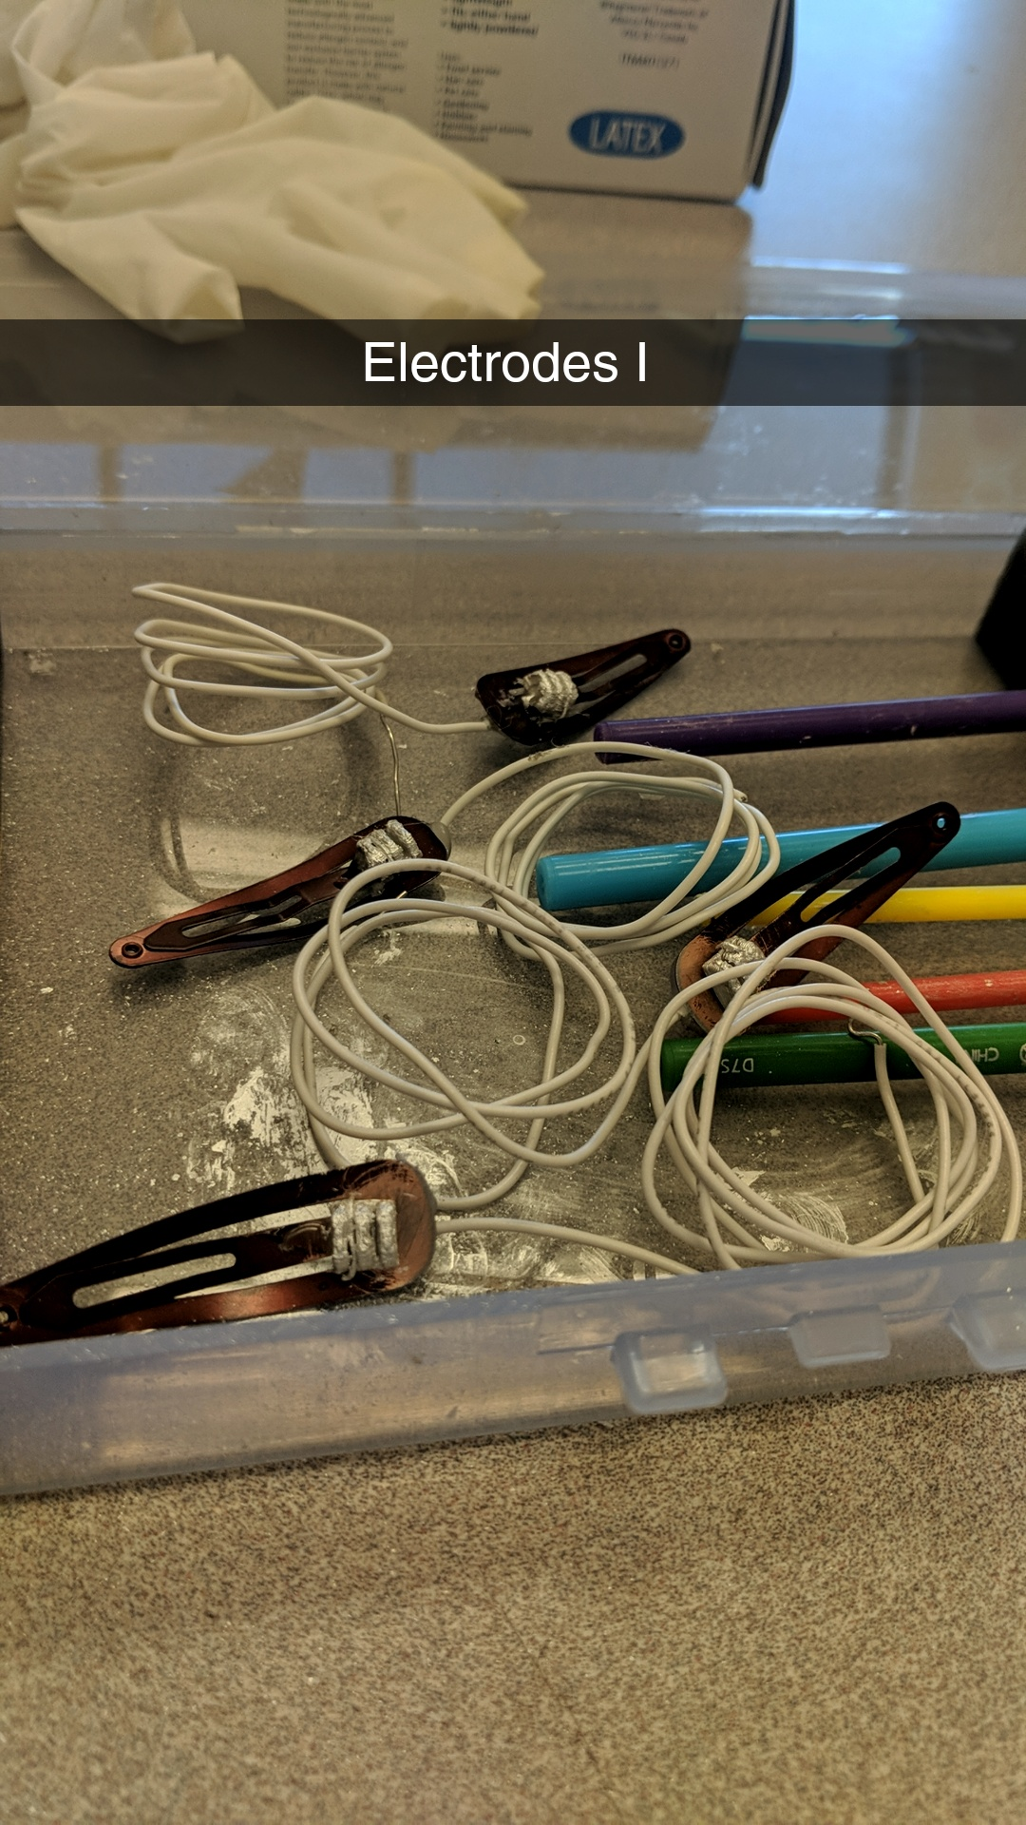

The hairpin electrodes were square-shaped, containing ridges that can penetrate through ize contact area with the scalp. Once printed, they can be painted with silver paint like the concave electrodes and then secured to any standard hair clips, such as barrettes, using hot glue. This facilitates attachment to hair while maintaining adequate scalp contact. The design of these electrodes were inspired by the following article: <http://ieeexplore.ieee.org/stamp/stamp.jsp?tp=&arnumber=7300517&tag=1>

**Battery Holder: **

Our battery holder was designed to give us approximately -5V to +5V, so batteries should be loaded into it as seen below. We set “ground” to be on the shelf (left) using some wire and rubber.



Above, you can see how we set up each terminal of our battery. We used four standard 3V CR1130 Lithium Ion batteries, but their output current turned out to be insufficient to sustain both boards, so this aspect of the design is not to be replicated. The dimensions of the battery holder may be easily altered in any CAD program to fit other batteries and deliver adequate current (~50mA).



**Central Shelf**

This shelf was designed to keep components separate and organized, with notches for the battery holder, screw holes for the circuit boards, and room for zip ties. You can see the fully assembled battery holder on the left, as well as an STL file of the full assembly enclosed.